**Object Oriented Programming**

**Packages:**

In simple words package is nothing but a folder. Location of the program you are running. If files are in same folder you don’t have to put import statement.

**STATIC:**

Object independent properties are called static. For Example property population is same for all human being for example it is 7billion for all the object of the class human.

To use the static variable use it with class name.   
it will also work with instance variable but good practice is to used with class name.

**STATIC METHOD IN NON STATIC METHOD:**

You can call static method in non static method.

**Non-Static in static method:**

You cannot call non static method in static variable. Because non static method need object to run while static is object independent.

**This keyword in static method**

You cannot use this keyword in static method since this is refer to instance of the class. And static is object independent.

**Outer Classes cannot be static.**

**Inner class can be statics:**

**Import Note:** if we use static in inner class then that mean class test does not depend upon object of outer class. But inner class can have its own separate object(only in case of inner class) other wise static don’t have separate objects.

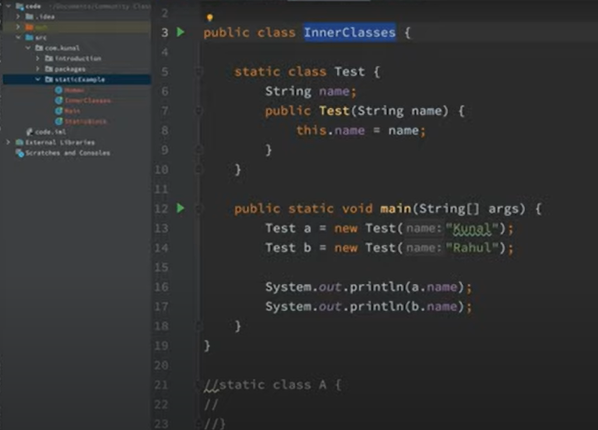

**OUTPUT:**

Answer in this case will be **Kunal, Rahul not Rahul Rahul.**

**Objects are created at runtime and static is independent of objects so Static is executed at compile time.**

**Singleton Class:**

Only one object of the class is created. Every time a constructor is called new object is created so to stop constructor to execute make it private.

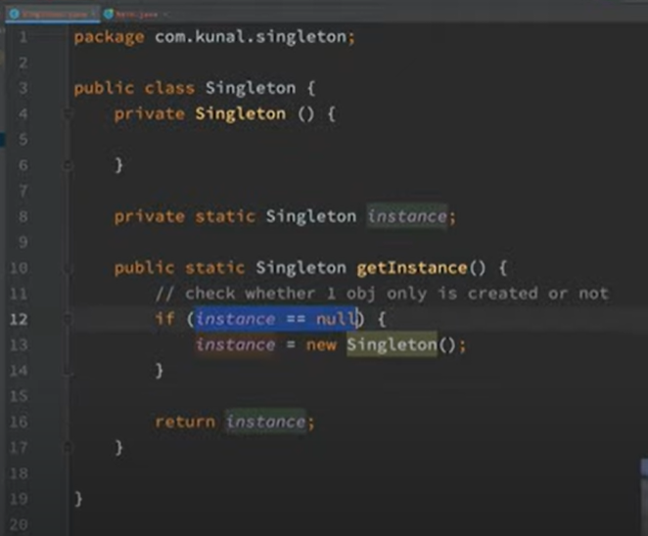

**No matter how many object you created all pointed to same instance**

**PILLARS OF OOP**

**Inheritance:**

We used **extend** keyword for inheritance.

When refence variable of Parent class and object type of child. Then we can only access the element which are of reference type not object type.

It is type of reference variable that determine the element we access not the object type.

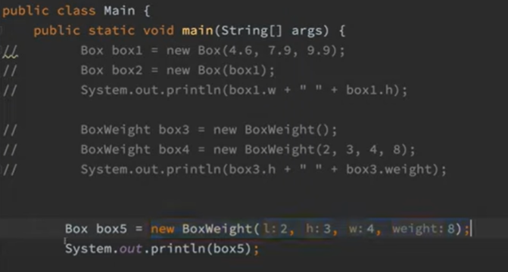

In this example box5 cannot access weight since it is only present in base class

BoxWeight not in Box class.

**Example 2**

When reference variable of child class and object type of parent class since parent class doesn’t know about weight variable and constructor will not called and thus weight is not initialized that is why giving error

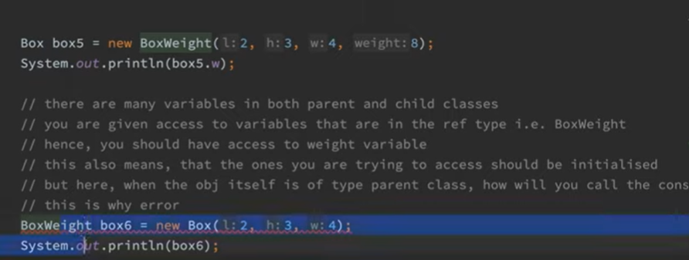

**TYPES OF INHERITANCE**

**Single Inheritance**

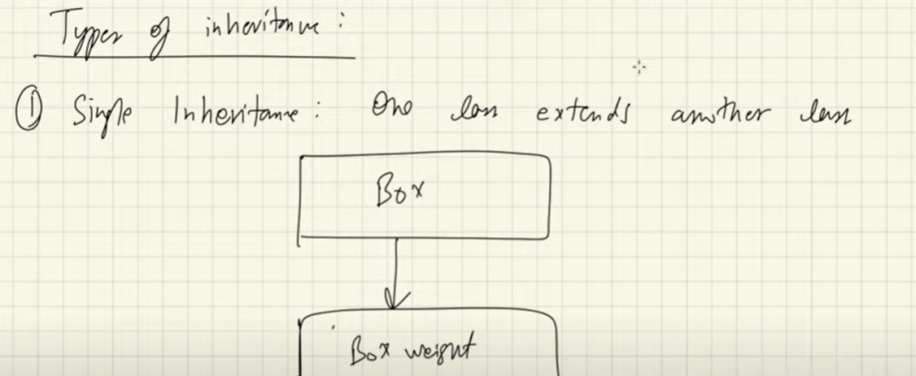

**Multilevel Inheritance:**

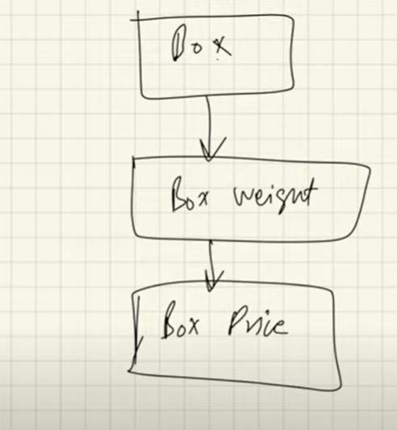

**Multiple Inheritance:**

One class can inherit more than one class. Not supported in java

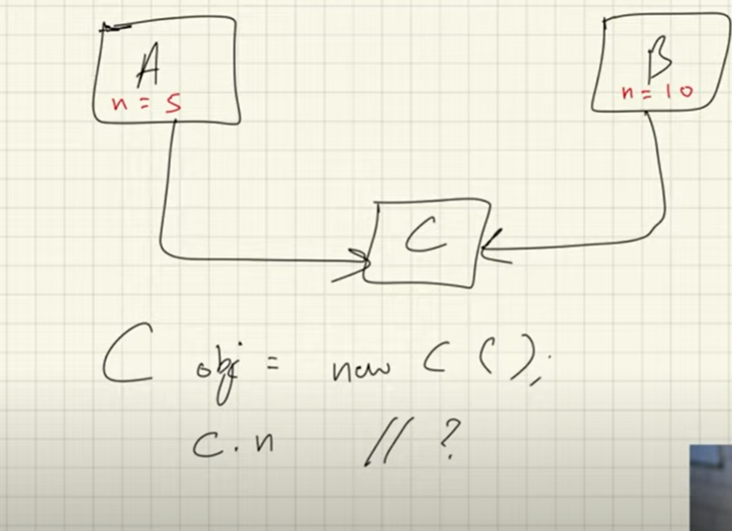

**Hierarchal Inheritance:**

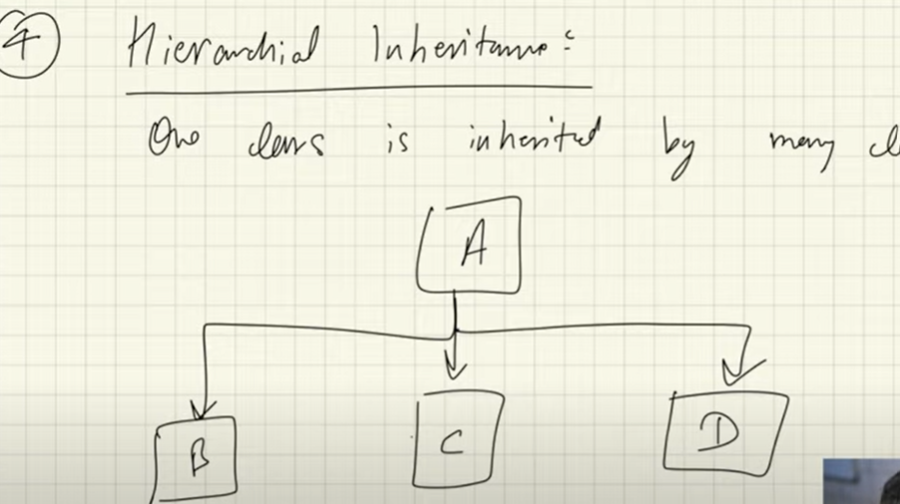

**Hybrid inheritance:**

Combination of single and multiple inheritance. (Not allow in java)

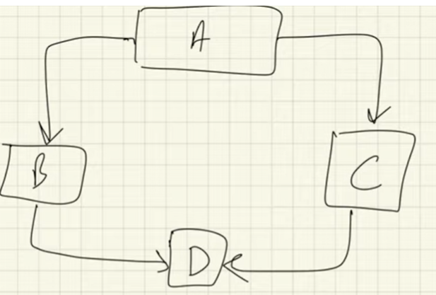

**Polymorphism:**

**Static or Compile time 🡪 🡪 Method Overloading**

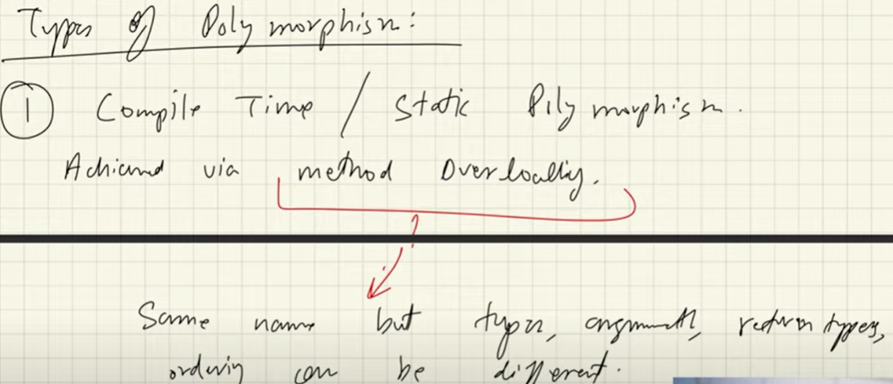

Compile time because java determine which method to be called in compile time.

**Runtime/ Dynamic 🡪 🡪 Method Overriding 🡪 late binding**

Same method with same number of argument and return type;

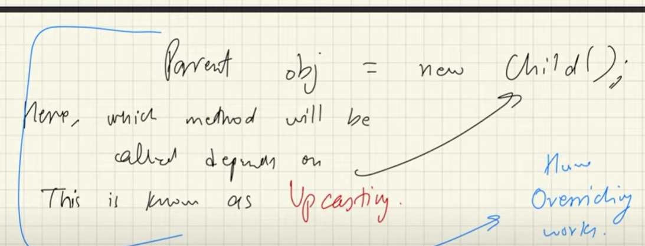

**static method can be inherited but cannot be overridden.**

**Overriding depends on object and static are object independent so static method cannot be overridden.**

**Encapsulation**

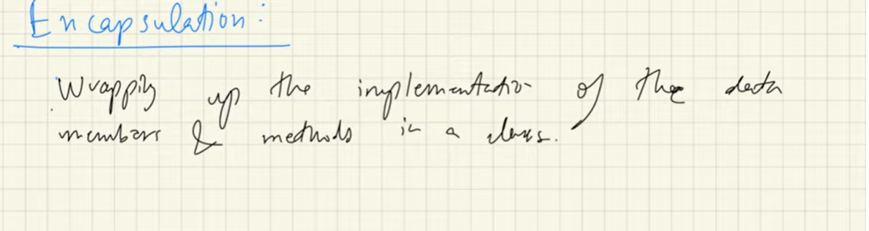

**Solving implementation level issue**

**Focus on internal stuff**

**Process of containing the information.**

**Abstraction**

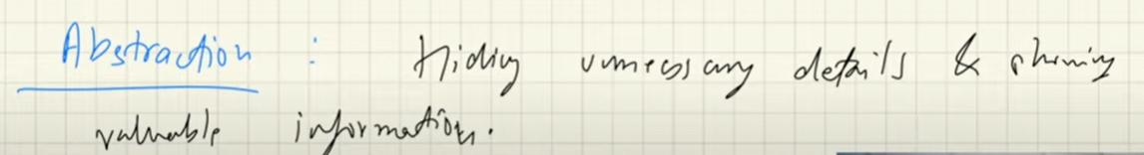

**Solving design level issue**

**Focus on external stuff.**

**Abstraction is process of gaining information.**

**Abstraction Method:**

In order to use Abstract method, you need to override them.

How to define:

abstract void function_name(parameter);

These methods Sare define child classes responsibility.

**Any class containing one or more abstract method must be declare as abstract.**

**You cannot create object of abstract class.**

**You cannot create abstract constructor.**